**CNS ASSIGNMENT-3**

**Name: Subhapreet Patro  
Roll No.: 2211CS010547  
Group: 3**

**1) Explain the authentication standards Kerberos with suitable diagram**

**A)**

**Understanding Kerberos Authentication Standards**

Kerberos is a network authentication protocol designed to provide secure authentication for users and services in a distributed environment. It uses secret-key cryptography to ensure that both the identity of the user and the integrity of the communication are protected. This document will explain the Kerberos authentication process and provide a suitable diagram to illustrate its components and workflow.

**Key Components of Kerberos**

1. **Key Distribution Center (KDC)**: The KDC is the central authority in the Kerberos protocol. It consists of two main parts:
   * **Authentication Server (AS)**: Responsible for verifying user credentials and issuing TGTs.
   * **Ticket Granting Server (TGS)**: Issues service tickets for accessing specific services after a TGT has been obtained.
2. **Client**: The user or service that requests authentication to access resources.
3. **Service**: The application or resource that the client wants to access.
4. **Ticket Granting Ticket (TGT)**: A temporary ticket issued by the AS that allows the client to request service tickets from the TGS.
5. **Service Ticket**: A ticket issued by the TGS that allows the client to authenticate to a specific service.

**Kerberos Authentication Process**

The Kerberos authentication process can be broken down into several steps:

1. **User Login**: The client enters their credentials (username and password) to log in.
2. **Request for TGT**: The client sends a request to the AS for a TGT, including their username.
3. **TGT Issuance**: The AS verifies the user's credentials. If valid, it sends back a TGT encrypted with the user's secret key and a session key.
4. **Request for Service Ticket**: The client decrypts the TGT using their secret key and sends a request to the TGS for a service ticket, including the TGT and the requested service's name.
5. **Service Ticket Issuance**: The TGS verifies the TGT and issues a service ticket encrypted with the service's secret key.
6. **Accessing the Service**: The client sends the service ticket to the service along with an authenticator (which includes the client's ID and a timestamp). The service decrypts the ticket and verifies the authenticator to grant access.

**Diagram of Kerberos Authentication Process**

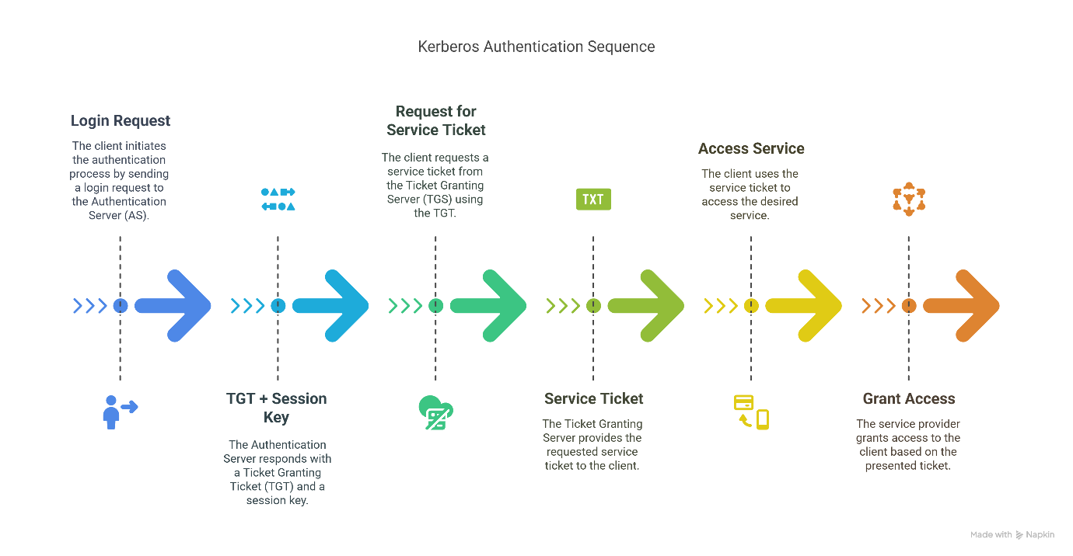

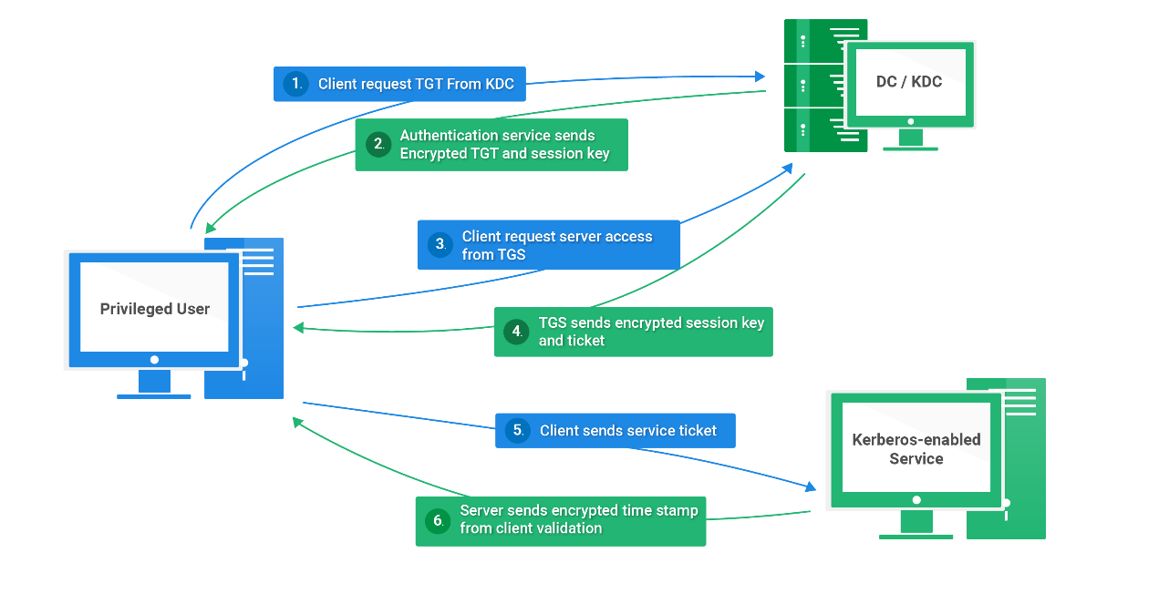

Kerberos is a robust authentication standard that enhances security in network environments by using tickets and secret-key cryptography. Understanding its components and processes is crucial for implementing secure authentication mechanisms in distributed systems. The diagram provided illustrates the flow of authentication, making it easier to grasp the interactions between clients, servers, and tickets in the Kerberos protocol.

**2) Describe the process of two-factor authentication (2FA). How does it enhance security compared to traditional password-based authentication?**

**A)**

**Two-Factor Authentication (2FA): A Robust Security Mechanism**

**Two-Factor Authentication (2FA)** is a powerful security measure designed to enhance the protection of user accounts and systems by requiring **two different types of verification** before granting access. This layered approach significantly reduces the risk of unauthorized access—even in cases where passwords are compromised.

**Understanding the Authentication Factors**

Authentication factors are categorized into three distinct types:

1. **Something You Know**  
   This includes knowledge-based credentials such as:
   * Passwords
   * PINs (Personal Identification Numbers)
   * Answers to security questions
2. **Something You Have**  
   These are possession-based factors, typically physical or digital objects the user owns:
   * Smartphones (used for receiving OTPs or using authenticator apps)
   * Hardware tokens (e.g., RSA SecurID, YubiKey)
   * Smart cards or USB security keys
3. **Something You Are**  
   This refers to biometric verification based on physical traits:
   * Fingerprints
   * Facial recognition (e.g., Face ID)
   * Retina or iris scans
   * Voice recognition

**How 2FA Works: Step-by-Step Breakdown**

Let’s walk through a typical 2FA process:

1. **Primary Authentication – "Something You Know"**  
   The user initiates login by entering a username and password. This is the first layer of security.
2. **Secondary Authentication – "Something You Have" or "Something You Are"**  
   Once the password is verified, the system requests a second form of authentication, which may include:
   * A **One-Time Password (OTP)** sent via SMS or email
   * A time-based code generated by **authenticator apps** such as Google Authenticator, Microsoft Authenticator, or Authy
   * A **hardware security key** (e.g., YubiKey or Titan Security Key)
   * **Biometric data** like a fingerprint or face scan, especially common on mobile devices
3. **Access Granted Upon Successful Verification**  
   If both factors are verified successfully, the user is granted access. If either factor fails, access is denied.

**Advantages of 2FA Over Traditional Passwords**

Two-Factor Authentication offers several critical security benefits:

1. **Mitigates Risks of Weak or Compromised Passwords**
   * Even if a password is stolen, guessed, or reused, it’s useless without the second factor.
   * 2FA neutralizes the impact of phishing, keyloggers, and data breaches that compromise credentials.
2. **Drastically Reduces Unauthorized Access**
   * Hackers need access to the second factor, often a physical device or biometric, which is harder to obtain remotely.
3. **Prevents Common Attack Vectors**
   * **Brute-force attacks**: Password guessing is rendered ineffective without the second layer.
   * **Credential stuffing**: Reused credentials from breached databases won’t work without the second factor.
   * **Phishing**: A stolen password won’t suffice if the attacker doesn’t have the additional authentication method.
4. **Supports Regulatory Compliance**
   * Industries handling sensitive data (e.g., banking, healthcare) often mandate 2FA under compliance frameworks like:
     + **PCI-DSS** (for payment processing)
     + **HIPAA** (healthcare)
     + **GDPR** (data privacy in the EU)
     + **NIST** guidelines for cybersecurity

**Limitations and Risks Associated with 2FA**

While 2FA significantly enhances security, it is not immune to threats:

* **SIM Swapping Attacks**
  + In SMS-based 2FA, attackers may use social engineering to transfer a victim’s phone number to a new SIM card, allowing them to intercept OTPs.
* **Advanced Phishing Techniques**
  + Some phishing campaigns mimic login portals and capture both the password and the OTP in real-time.
* **Device Dependency**
  + If a user loses access to their phone, hardware token, or authenticator app, they may be locked out of their account without backup options.
* **Inconvenience**
  + Some users perceive 2FA as an extra step, leading to frustration or attempts to disable it.

**Best Practices for Strong and Effective 2FA Implementation**

To maximize the benefits of 2FA and minimize its downsides:

1. **Avoid SMS-Based 2FA When Possible**
   * Prefer **TOTP-based apps** like Google Authenticator or Authy for generating time-sensitive codes.
2. **Leverage Hardware Security Keys for Critical Systems**
   * Devices like **YubiKey** offer the highest protection against phishing and man-in-the-middle attacks.
3. **Enable Biometric Authentication Where Supported**
   * Utilize built-in features like Touch ID or Face ID for added convenience and security.
4. **Use Backup Methods**
   * Set up recovery codes or alternative authentication options to avoid account lockout in case of device loss.
5. **Educate Users**
   * Users should be trained to recognize phishing attempts and understand how to use 2FA securely.

Two-Factor Authentication is a vital component of modern cybersecurity. It strikes a balance between usability and security by adding an essential layer of defense against a wide range of cyber threats. While not foolproof, when implemented and managed correctly, 2FA dramatically reduces the likelihood of unauthorized access and data breaches.

**3) Explain the role of E-mail Security. How PGP will help for E-mail security.**

**A)**

**The Role of Email Security & How PGP Enhances It**

**1. Why Email Security Matters**

Email is the backbone of modern communication, especially in professional and governmental environments. However, because of its widespread use and often minimal default protection, it is a high-value target for cybercriminals.

**Common Threats to Email Security**

* **Phishing Attacks**: Attackers impersonate trusted sources to steal login credentials or trick users into revealing sensitive data.
* **Man-in-the-Middle (MITM)**: Attackers intercept emails between sender and receiver—often during transit over unsecured networks.
* **Data Breaches**: If a mail server is hacked, unencrypted emails stored on it can be stolen or tampered with.
* **Malware Attachments**: Emails are a common delivery method for malware, spyware, and ransomware.
* **Spoofing**: Fraudsters forge sender addresses to deceive recipients into trusting malicious emails.

**Core Security Goals**

Email security aims to achieve the following:

* **Confidentiality**: Messages should only be read by intended recipients.
* **Integrity**: Messages should not be altered during transmission.
* **Authentication**: The recipient should be able to verify who sent the message.
* **Non-repudiation**: The sender should not be able to deny sending the message.

**2. What is PGP and How It Secures Emails**

**What is PGP?**

**Pretty Good Privacy (PGP)** is a widely used data encryption program that provides **cryptographic privacy and authentication**. It combines **symmetric-key encryption** and **public-key cryptography** to secure email content, attachments, and metadata.

It was originally developed by **Phil Zimmermann** in 1991 and is now maintained via **open-source implementations** like **GPG (GNU Privacy Guard)**.

**3. How PGP Enhances Email Security**

**A. End-to-End Encryption (E2EE)**

* Ensures that only the **intended recipient** can read the message.
* Encrypts data **before it leaves the sender's device**, and it stays encrypted until it’s decrypted by the recipient.

**B. Digital Signatures**

* Provides **authentication** by letting recipients verify that a message was **sent by a trusted party**.
* Ensures **integrity** by detecting any tampering during transit.

**C. Integrity Protection**

* Even a single bit change in the message results in signature verification failure, alerting the recipient.

**D. Non-Repudiation**

* Digital signatures bind the message to the sender’s private key, meaning they **cannot plausibly deny** having sent it.

**4. How PGP Works (Step-by-Step Process)**

**A. Key Generation**

Each user generates:

* A **Public Key**: Shared openly, used for encrypting emails and verifying signatures.
* A **Private Key**: Kept secret, used for decrypting emails and creating digital signatures.

These keys form a **key pair** that mathematically work together.

**B. Encryption (Sender Side)**

1. The sender writes a message.
2. PGP generates a **random symmetric session key** (AES is commonly used).
3. The email is encrypted using the session key (**fast symmetric encryption**).
4. The session key is then **asymmetrically encrypted** using the recipient’s **public key**.
5. The encrypted session key and message are bundled and sent.

**C. Decryption (Recipient Side)**

1. The recipient uses their **private key** to decrypt the session key.
2. The session key is then used to **decrypt the email content**.

**D. Digital Signing**

1. The sender hashes the message to create a **unique message digest**.
2. The digest is **encrypted using the sender’s private key** (digital signature).
3. The recipient:
   * Decrypts the signature with the sender’s public key.
   * Hashes the received email.
   * Compares both digests to ensure authenticity and integrity.

**5. Comparison: PGP vs. Other Email Security Solutions**

|  |  |  |  |  |
| --- | --- | --- | --- | --- |
| **Feature** | **PGP** | **S/MIME** | **TLS** | **No Encryption** |
| **Encryption Scope** | End-to-End | End-to-End | Transit Only | None |
| **Authentication** | Digital Signatures | Certificates | None | None |
| **Key Management** | Decentralized (Web of Trust) | Centralized (CA-based) | Handled by servers | None |
| **Usability** | Medium (Manual Setup) | Easy (Built-in) | Seamless | Very Easy |
| **Popular Tools** | GPG, Mailvelope, Thunderbird | Outlook, Apple Mail | Gmail, Yahoo | Basic clients |

**6. Challenges and Best Practices for PGP Users**

**A. Common Challenges**

* **Key Management**: Users must safeguard their private key and manage public key trust manually.
* **Complex Setup**: Not user-friendly out-of-the-box; requires plugins or specialized email clients.
* **Compatibility**: Mainstream email providers like Gmail or Outlook don’t natively support PGP.
* **Revocation Issues**: Revoking compromised keys and redistributing new ones can be complex.

**B. Best Practices**

* Always **backup your private key** securely (e.g., offline USB in encrypted storage).
* Use tools like:
  + **GnuPG (GPG)** – CLI & GUI-based key management.
  + **Mailvelope** – Browser plugin for Gmail/Yahoo.
  + **Thunderbird with OpenPGP** – Full-featured email + PGP integration.
* **Use fingerprint verification** for key authenticity (avoid MITM attacks).
* Combine **PGP with TLS** for layered security (TLS for transmission, PGP for content).
* Set **expiration dates** for keys and rotate them regularly.

**7. Real-World Use Cases**

* **Whistleblowers & Investigative Journalism**
  + Used in platforms like **SecureDrop** and **GlobaLeaks** to protect anonymity.
* **Law Firms & Financial Institutions**
  + Secure sensitive legal contracts, audit reports, and trade secrets.
* **Health Sector & Academia**
  + Protect patient records, medical research, and confidential collaboration.
* **Individuals Concerned with Privacy**
  + Activists, tech enthusiasts, or anyone avoiding surveillance or censorship.